Group Project Report Template

First A. Author, Second B. Author, and Third C. Author

I. Introduction

This template is adapted from the IEEE Transactions on Power Electronics paper template. Use this template for your report and review the formatting instructions.

A. Preparing your Electronic Paper
Prepare your paper in full-size format, on US letter paper (8.5 x 11 inches). For A4 paper, use the A4 settings. The body text should be justified and use Times New Roman 12-point font with single-line spacing.

Table I: Example Table Format

Parameter | Value
Input voltage V_{g} | 12 V – 48 V
Output voltage V_{o} | 5 V
Output voltage ripple Δv | 1% of V_{o}
Output power P | 25 W
Switching frequency f_{sw} | 100 kHz
Inductor current ripple Δi_{M} | 20% of I_{M}

II. Additional Requirements
In this section, additional requirements for figures and tables, references, and equations will be discussed.
A. Figures and Tables
Position figures and tables at the tops and bottoms of columns. Avoid placing them in the middle of columns. Large figures and tables may span across both columns. Figure captions should be aligned left below the figures; table captions should be centered above. All figures and tables should be mentioned (introduced and explained) in the text. Avoid placing figures and tables before their first mention in the text. Use “Figure 1” in text when introducing, describing, and/or referring to the figure, and bold the text.
Figure axis labels are often a source of confusion. Use words rather than symbols. For example, write “Current,” or “Current (A)” not just “A”. Put units in parentheses. Do not label axes only with units. In the example, write “Magnetization (A/m)” or “Magnetization (A·m¹).” Do not label axes with a ratio of quantities and units. For example, write “Current (A),” not “Current/A.”
Multipliers can be especially confusing. Write “Magnetization (kA/m)” or “Magnetization (10³ A/m).” Figure labels should be legible, and be no smaller than 10-point type.

B. References
Number reference citations consecutively in square brackets [1]. The sentence punctuation follows the bracket [2]. Refer simply to the reference number, as in [3]. Use “Ref. [1]” or “Reference [1]” at the beginning of a sentence.
Number footnotes separately in superscripts. Place the actual footnote at the bottom of the column in which it is cited. Do not put footnotes in the reference list. Use letters for table footnotes (see Table I). IEEE Transactions no longer use a journal prefix before the volume number. For example, use “IEEE Trans. Magn., vol. 25,” not “vol. MAG-25.”

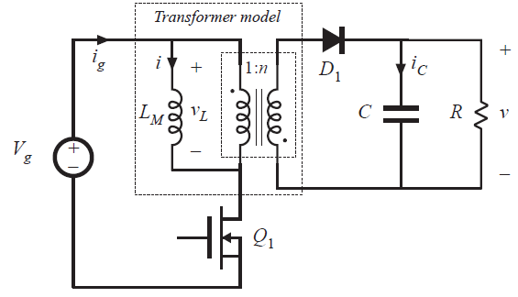
Figure 1: Note that “Figure” is bolded, and there is a colon after the figure number. It is good practice to explain the significance of the figure in the caption. Note: font sizes should be no smaller than those shown in this example figure.
Give all authors’ names; use “et al.” if there are six authors or more. Papers that have not been published, even if they have been submitted for publication, should be cited as “unpublished.” Papers that have been accepted for publication should be cited as “in press.” In a paper title, capitalize the first word and all other words except for conjunctions, prepositions less than seven letters, and prepositional phrases.

C. Abbreviations and Acronyms
Define abbreviations and acronyms the first time they are used in the text, even if they have been defined in the abstract. Abbreviations such as IEEE, SI, MKS, CGS, ac, dc, and rms do not have to be defined. Do not use abbreviations in the title unless they are unavoidable.

D. Equations
Number equations consecutively with equation numbers in parentheses flush with the right margin, as in (1). To make your equations more compact, you may use the solidus ( / ), the exp function, or appropriate exponents. Italicize Roman symbols for quantities and variables, but not Greek symbols. Use an en dash (–) rather than a hyphen for a minus sign. Use parentheses to avoid ambiguities in denominators. Punctuate equations with commas or periods when they are part of a sentence, as in
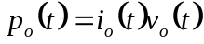. (1)
Symbols in your equation should be defined before the equation appears or immediately following. Use “(1),” DO NOT use “Eq. (1)” or “equation (1),” except at the beginning of a sentence: “Equation (1) is …”

E. Other Recommendations
The Roman numerals used to number the section headings are optional. If you do use them do not number ACKNOWLEDGMENT and REFERENCES, and begin Subheadings with letters. Use two spaces after periods (full stops). Hyphenate complex modifiers: “zero-field-cooled magnetization.” Avoid dangling participles, such as, “Using (1), the potential was calculated.” Write instead, “The potential was calculated using (1).”
Use a zero before decimal points: “0.25,” not “.25.” Use “cm³,” not “cc.” Do not mix complete spellings and abbreviations of units: “Wb/m²” or “webers per square meter,” not “webers/m².” Spell units when they appear in the text: “…a few henries,” not “…a few H.” If your native language is not English, try to get a native English-speaking colleague to proofread your paper.

III. Units
Metric units are preferred for use in IEEE publications. British units may be used as secondary units (in parentheses). An exception would be the use of British units as identifiers in trade, such as “3.5-inch disk drive.”
Avoid combining SI and CGS units, such as current in amperes and magnetic field in oersteds. This often leads to confusion because equations do not balance dimensionally. If you must use mixed units, clearly state the units for each quantity that you use in an equation.

Appendix
Appendixes, if needed, appear before the references.

References
[1] G. Dawson and I. N. Chan, “A modified zero-voltage-switching flyback converter,” IEEE Trans. Power Electron., vol. 9, no. 2, pp. 129-135, Apr 1994.
[2] Y. Zhi, T. Kaynak, and W. Zhang, “Modified maximum power point tracking technique for wind energy application,” IEEE Trans. Power Electron., vol. 27, no. 7, pp. 3023-3027, Jul 2012.
[3] F. Zhang, “A new high power factor AC-AC inverter,” IEEE Power Electron. Lett., vol. 1, no. 5, pp. 10–13, Mar. 2000.


First A. Author The author’s educational background is listed. The degrees should be listed with type of degree in what field, which institution, city, state, and country, and year the degree was earned (or expected to be earned). The author’s major field of study should be lower-cased. The author’s areas of interest within the field could be listed.
In the second paragraph, briefly describe the team member’s contributions to the project and report.

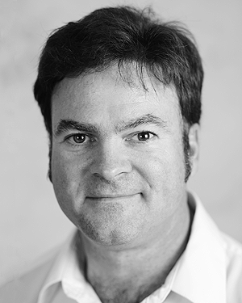
Second B. Author received the B.S. and M.S. degrees in electrical engineering from the University of Virginia, Charlottesville, in 2001 and the Ph.D. degree in mechanical engineering from Drexel University, Philadelphia, PA, in 2008. His areas of interest include microelectronics packaging and reliability.
For the group project, he led the thermal design and contributed to the materials selection. For the report, he led the thermal design section writeup and contributed to the overall review of the report and formatting of the references.

